Time Management Report
DATE: June 5, 2015
To: Professor Li
From: Song Wenbo
SUBJECT: Time Management Report for the Third Semester.

Student Information
Class Number: 2013215107
Name (Write in the next row )
In Chinese :宋文博 | In PinYin :Songwenbo
Student Number (Write in the next row )
BUPT:  2013213112 | QM:  130800938
Targets in This Semester (The most important three targets)
1. Rank top 10% in the end of this semester on the base of top 15% of this year. To achieve this target, I will take following measures; take two hours to review lecture and another hour to do extra exercise every day.
2. Prepare TOEFL Test in February 2015 to get a score higher than 100 at the first try. I will put two hours per day in this target to practice mainly four things including speaking, listening, reading and writing.
3.Taking part in exercise in order to build a healthy body.(1 hour a day)
Analysis (Use suitable diagram to show how you spent time during the past months)
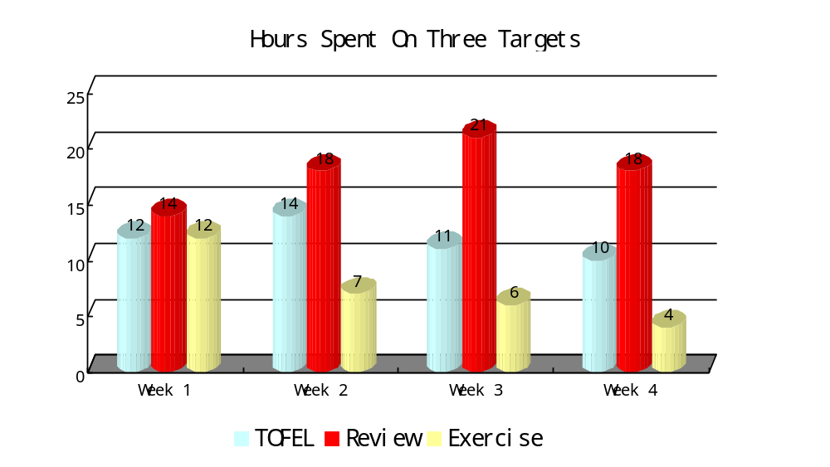diagram 1-1
Analysis: From the diagram 1-1 we can learn that, at the beginning, with few homework and great enthusiasm, I spent a lot of time in exercise, but as time goes on, I have to devote more time in professional courses, so exercise time became less and less. However the time spent on TOEFL has always been the same, which brought a good effect on my TOEFL study.
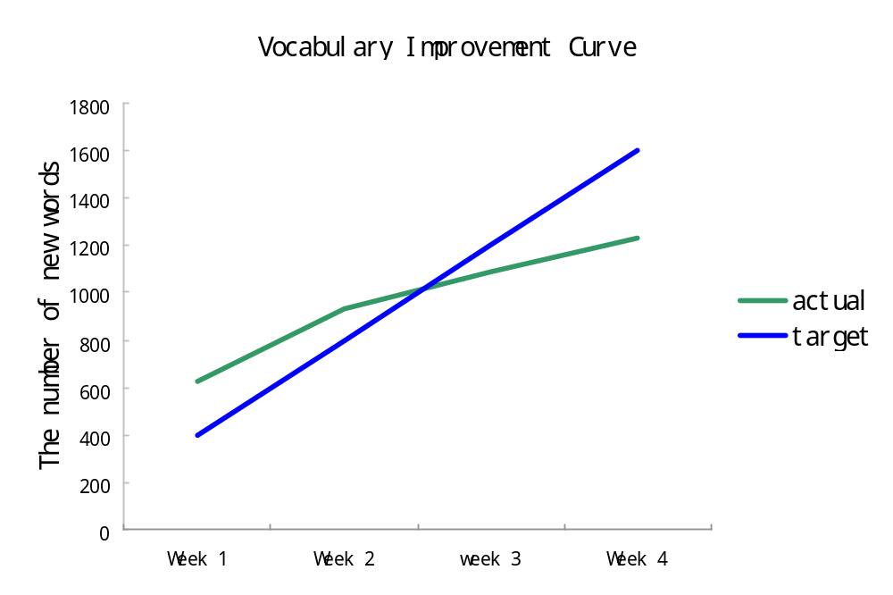
diagram 1-2
Analysis: From the diagram 1-2, we can learn that at the first week, the target is perfectly finished, even went ahead of the plan, but as the time devoted in learning increased, the number of new words fell behind the target at last
. 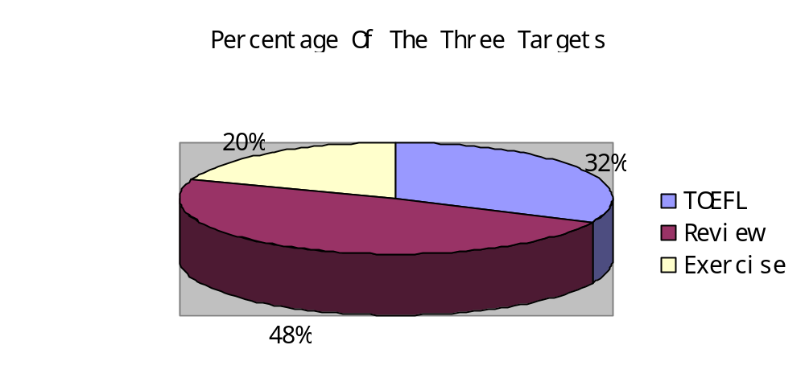
diagram 1-3
Analysis: From diagram 1-3, we can learn that, Review took nearly half of the whole time of my three targets. The second one is TOEFL learning, which should have occupied more percentage. At the last is exercise, obviously, it was always occupied by review which reflected by the diagram.

Does your performance accord to your targets? 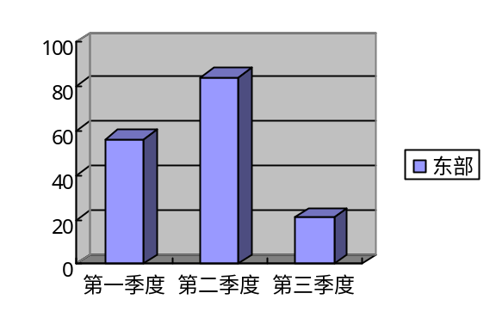

■YES □NO
Problems and Solutions (Any possible improvement)
Problems:
- Wasn’t made the best of the trivial time which causes many detailed work unfinished. Can guarantee the time but not with the high efficiency.
- Have great enthusiasm at the beginning but as time goes on, enthusiasm began to fade out and many targets were failed, which is mainly reflected in body exercise.
- Although gained a lot from the TOEFL classes, I need to learn more by myself.
Solutions:
To do better in the next period, I would try to do the following things:
- Cut the time in more detailed pieces; arrange more targets in one period which won’t make me feel boring anymore.
- Try to put the more interesting things in the end of the term to promote the complement of the targets.
- Check my schedule regularly. Every morning when I get up, I would check my plan to remind me of the things to do today. Every Sunday, I would check the rate of progress and see if there is something I can add, delete or modify which build on those that have been completed. As to those uncompleted plans, I would give them higher priority in next week instead of letting them go.
- Go out of my circle, to talk and cooperate with my friends. I would like to have some close friends to supervise me as, sometimes, tell others my plan would give me more motivation to accomplish my targets.

